Experiment–3: I-V Characteristics of Diode

Group no: - 14 Date of Experiment: - 10/08/2023
Roll no: - 22CS02002 Name: - Soham Chakraborty

Part-1: Forward Characteristics of Various Diodes

Aim of the Experiment: - Observe and measure the forward bias I-V characteristics of a
p-n Silicon diode (1N4007), Zener diode and LED.

Equipments required: -
▶ Required resistor values– 1 kΩ (×2), 100Ω (×1)
▶ Variable DC power supply ( 0-15V )
▶ 1N4007 Silicon diode, Zener diode, LED
▶ Multimeter
▶ Breadboard (×1)
▶ Connecting wires

Circuit Diagram: -
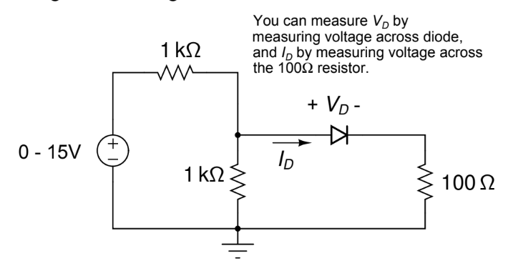

Part-1A: Forward Characteristics of Si Diode

Observation Table: -

DC Supply  (Volts) | Voltage across diode V_{D}  (mV) | Voltage across  100Ω resistor V_{R}  (mV) | Diode Current  I_{D} = V_{R}/100  (mA)
0 | 0 | 0 | 0
0.5 | 257 | 0 | 0
0.7 | 347 | 0.3 | 0.003
1 | 470 | 2 | 0.02
1.2 | 524 | 11 | 0.11
1.5 | 575 | 29 | 0.29
1.8 | 588 | 51 | 0.51
2 | 603 | 66 | 0.66
2.3 | 616 | 90 | 0.9
2.5 | 621 | 105 | 1.05
2.8 | 636 | 129 | 1.29
3 | 641 | 145 | 1.45
4 | 660 | 226 | 2.26
5 | 671 | 311 | 3.11
6 | 682 | 392 | 3.92
7 | 688 | 483 | 4.83
8 | 705 | 564 | 5.64
9 | 732 | 585 | 6.51
10 | 783 | 625 | 7.55

Theoretically calculated vs observed graph values:-

Cut-in Voltage: 636 mV

Calculation: -
The voltage across the 100Ω resistor was measured using a multimeter and then the current through the diode was calculated using Ohm’s Law:
I_{D} = $\frac{VR}{R}$
Forward resistance:
r_{on} = $\frac{dVd}{dId} ≈ \frac{1}{m}$

Taking the two points (0.641,1.5) and (0.682,3.94) in the ON region of the curve we have the slope of the curve m = 0.0595
Hence, r_{on} = 16.80Ω
From Shockley’s equation:
I_{D} $≈$ I_{S}$e^{\frac{Vd}{nVt}}$ I_{S} = Reverse bias saturation current
$∴$ln(I_{D}) $= \frac{Vd}{nVt}+$ ln(I_{S}) n = Diode ideality factor V_{T} = Thermal Voltage $≈$ 26mV

Taking the two points (0.636,0.293) and (0.682,1.371) from the graph of ln(I_{D}) vs V_{D} we have the slope of the graph at ON position equal to 0.0234 (mV)⁻¹.
Now, slope of the graph:
m = $\frac{1}{n .Vt}$
or, n = $\frac{1}{m. Vt}$
Hence, we get n = 1.644.
Taking the point (0.66,0.837) on the graph of ln(I_{D}) vs V_{D} and putting values on Shockley’s equation. We get,
I_{S} $≈$ 0.45 nA

Part-1B: Forward Characteristics of Zener Diode

Observation Table: -

DC Supply  (Volts) | Voltage across diode V_{D}  (mV) | Voltage across  100Ω resistor V_{R}  (mV) | Diode Current  I_{D} = V_{R}/100  (mA)
0 | 0 | 0 | 0
0.5 | 248 | 0 | 0
1 | 486 | 1.1 | 0.011
1.2 | 566 | 5.6 | 0.056
1.5 | 629 | 19.3 | 0.193
1.7 | 653 | 32.2 | 0.322
2 | 678 | 54.6 | 0.546
2.2 | 687 | 70 | 0.7
2.5 | 700 | 97 | 0.97
2.8 | 705 | 109.2 | 1.09
3 | 713 | 134 | 1.34
3.5 | 723 | 175 | 1.75
3.8 | 728 | 198.5 | 1.985
4 | 730 | 216.4 | 2.164
5 | 740 | 290 | 2.9
6 | 745 | 380 | 3.8

Graphs:-

Cut-in Voltage: 687 mV

Calculation: -
The voltage across the 100Ω resistor was measured using a multimeter and then the current through the diode was calculated using Ohm’s Law:
I_{D} = $\frac{VR}{R}$
Forward resistance:
r_{on} = $\frac{dVd}{dId} ≈ \frac{1}{m}$

Taking the two points (705,1.092) and (728,1.985) in the ON region of the curve we have the slope of the curve m = 0.0388
Hence, r_{on} = 25.76Ω
From Shockley’s equation:
I_{D} $≈$ I_{S}$e^{\frac{Vd}{nVt}}$ I_{S} = Reverse bias saturation current
$∴$ln(I_{D}) $= \frac{Vd}{nVt}+$ ln(I_{S}) n = Diode ideality factor V_{T} = Thermal Voltage $≈$ 26mV

Taking the two points (566,-2.882) and (678,-0.605) from the graph of ln(I_{D}) vs V_{D} we have the slope of the graph at ON position equal to 0.0203 (mV)⁻¹.
Now, slope of the graph:
m = $\frac{1}{n .Vt}$
or, n = $\frac{1}{m. Vt}$
Hence, we get n = 1.892.
Taking the point (629,-1.645) on the graph of ln(I_{D}) vs V_{D} and putting values on Shockley’s equation. We get,
I_{S} $≈$ 0.55 nA

Part-1C: Forward Characteristics of LED

Observation Table: -

DC Supply  (Volts) | Voltage across diode V_{D}  (in V) | Voltage across  100Ω resistor V_{R}  (mV) | Diode Current  I_{D} = V_{R}/100  (mA)
0 | 0 | 0 | 0
0.5 | 0.254 | 0 | 0
1 | 0.506 | 0 | 0
2 | 1 | 0 | 0
3 | 1.5 | 0.1 | 0.001
4 | 1.762 | 41.2 | 0.412
5 | 1.81 | 122.1 | 1.221
6 | 1.834 | 196.4 | 1.964
7 | 1.854 | 280.9 | 2.809
8 | 1.869 | 362.9 | 3.629
9 | 1.882 | 447 | 4.47
10 | 1.893 | 530 | 5.3
11 | 1.903 | 613 | 6.13
12 | 1.912 | 698 | 6.98
13 | 1.92 | 777 | 7.77
14 | 1.928 | 870 | 8.7
15 | 1.935 | 955 | 9.55

Graphs:-

Cut-in Voltage: 1.762 V
Color of LED: Red

Calculation: -
The voltage across the 100Ω resistor was measured using a multimeter and then the current through the diode was calculated using Ohm’s Law:
I_{D} = $\frac{VR}{R}$
Forward resistance:
r_{on} = $\frac{dVd}{dId} ≈ \frac{1}{m}$

Taking the two points (1.854,2.809) and (1.92,7.77) in the ON region of the curve we have the slope of the curve m = 0.0752
Hence, r_{on} = 13.31Ω
From Shockley’s equation:
I_{D} $≈$ I_{S}$e^{\frac{Vd}{nVt}}$ I_{S} = Reverse bias saturation current
$∴$ln(I_{D}) $= \frac{Vd}{nVt}+$ ln(I_{S}) n = Diode ideality factor V_{T} = Thermal Voltage $≈$ 26mV

Taking the two points (1.834,0.675) and (1.912,1.943) from the graph of ln(I_{D}) vs V_{D} we have the slope of the graph at ON position equal to 0.0223 (mV)⁻¹.
Now, slope of the graph:
m = $\frac{1}{n .Vt}$
or, n = $\frac{1}{m. Vt}$
Hence, we get n = 1.725.
Taking the point (1.882,1.5) on the graph of ln(I_{D}) vs V_{D} and putting values on Shockley’s equation. We get,
I_{S} $≈$ 0.65 nA

Part-2: Reverse Characteristics of Zener Diode

Aim of the Experiment: - Observe and measure the reverse bias I-V characteristics of Zener diode.

Equipments required: -
▶ Required resistor values– 1 kΩ (×1)
▶ Variable DC power supply ( 0-15V )
▶ Zener diode
▶ Multimeter
▶ Breadboard (×1)
▶ Connecting wires

Circuit Diagram: -
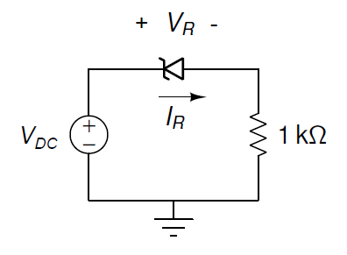

Observation Table: -

DC Supply  (Volts) | Diode reverse voltage V_{D}  (in V) | Voltage across  1kΩ resistor V_{R}  (in V) | Diode Current  I_{D} = V_{R}/1000  (mA)
0 | 0 | 0 | 0
1 | 1 | 0 | 0
2 | 1.99 | 0.01 | 0.01
3 | 2.98 | 0.02 | 0.02
3.5 | 3.42 | 0.073 | 0.073
3.75 | 3.61 | 0.13 | 0.13
4 | 3.8 | 0.2 | 0.2
4.25 | 3.95 | 0.29 | 0.29
4.5 | 4.04 | 0.37 | 0.37
4.8 | 4.2 | 0.58 | 0.58
5 | 4.26 | 0.72 | 0.72
5.5 | 4.37 | 1.11 | 1.11
6 | 4.45 | 1.51 | 1.51
7 | 4.56 | 2.1 | 2.1
8 | 4.71 | 3.25 | 3.25
9 | 4.73 | 4.22 | 4.22
10 | 4.74 | 5.32 | 5.32

Graph:-

Reverse Breakdown Voltage: 4.26 V

Conclusion: -
- In this experiment we have practical understanding on how to use Si, Zener and LED Diode in forward and reverse bias in Zener diode.
- The input-output characteristics of diodes in forward and reverse bias were plotted and inference was drawn from those graphs on cut-in voltage and reverse breakdown voltage.
- Slight errors in the measurement of Voltage was observed, this was due to prolonged use of breadboard and the same 1k resistor. This resulting in heating up of circuit and thus the thermal tolerances of the circuit added to the error.

Discussion:-

- What is Shockley’s equation?
The Shockley diode equation or the diode law, named after transistor co-inventor William Shockley of bell labs, models the exponential current-voltage I-V relationship of semiconductor diodes in moderate constant current forward bias or reverse bias.
It is given by the formula:
I_{D} $≈$ I_{S}$e^{\frac{Vd}{nVt}}$
$∴$ ln(I_{D}) $= \frac{Vd}{nVt}+$ ln(I_{S})
I_{D} = Diode current
V_{D} = Voltage across diode
I_{S} = Reverse bias saturation current
n = Diode ideality factor
V_{T} = Thermal Voltage $≈$ 26mV
Shockley’s equation is not valid for reverse-biased Zener diodes.

- What does ideality factor represent in Shockley’s equation?
The ideality factor (n) in the Shockley diode equation represents a correction factor that accounts for deveiation from ideality in a real diode's behavior. In other words, it quantifies how closely a real diode's behavior matches the ideal diode behavior described by the equation. The value of idelaity factor varies from 1 to 2. 1 representing an ideal diode.

